# **Suggestions for our Research**

1. **Sample Size, Population, and Reliability Checks**
   * Sample Description
     + Sample Size: The survey collected responses from 50 volunteers, representing approximately 33% of the total Sustainable Merton volunteer population (150 individuals).
     + Demographics:
       1. The dataset includes key demographic variables such as age, gender identity, and ethnic background, which allow for an assessment of diversity within the sample.
       2. Volunteers’ levels of involvement are reflected through engagement and commitment measures.
   * Representativeness
     + The sample size is moderate, covering one-third of the population, providing a snapshot of the target group. However:
     + Strength: A third of the population is significant for volunteer studies.
     + Limitations: The small sample size limits generalizability to the broader Sustainable Merton volunteer base. There may also be potential response bias, as more engaged volunteers might be overrepresented.
   * Reliability Checks
     + To calculate Cronbach’s Alpha, I used Python, leveraging statistical libraries to ensure accuracy and efficiency. First, I gathered responses for all items within each scale (e.g., Motivation, Engagement, Satisfaction) and ensured the data was properly aligned. Using the variance formula, I computed the variance for each individual item and the total variance across all items. These were then applied to the Cronbach’s Alpha formula, where is the number of items in the scale. The resulting Alpha value, 0.872, indicates high internal consistency, confirming the reliability of the scales used in the survey.
     + Cronbach’s Alpha for the scales is 0.872, indicating excellent internal consistency. This suggests that the scales used to measure Motivation, Engagement, and Satisfaction are reliable.
   * Summary of Average Scores
     + Motivation (scale: 1–7):
       1. Career: 2.83 - Relatively low, indicating less career-oriented motivation.
       2. Social: 3.58 - Moderate, reflecting some social motivations.
       3. Values: 6.02 - Very high, showing strong alignment with personal values.
       4. Understanding: 5.18 - High, suggesting volunteers seek knowledge or self-development.
       5. Enhancement: 4.31 - Moderate, reflecting some desire for self-growth.
       6. Protection: 4.14 - Moderate, showing some concern for self-protection.
     + Engagement (scale: 1–7):
       1. Vigor: 4.09 - Moderate, suggesting average energy levels in volunteering.
       2. Dedication: 5.03 - High, indicating strong emotional commitment.
       3. Absorption: 4.19 - Moderate, reflecting moderate involvement in activities.
     + Satisfaction (scale: 1–7):
       1. Task: 5.95 - Very high, showing satisfaction with the tasks performed.
       2. Organization: 5.42 - High, indicating satisfaction with Sustainable Merton’s management.
     + Commitment (scale: 1–5): 3.67 - Moderate, reflecting some intent to continue volunteering.
   * Conclusions
     + The sample is diverse enough to provide insights into the volunteer population’s motivations, engagement, and satisfaction.
     + High reliability of scales ensures robust findings.
2. **Overview of Core Constructs**

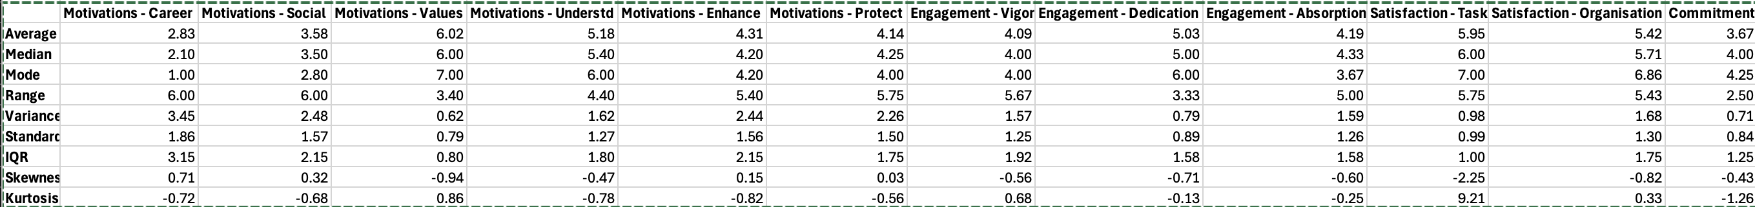

* Motivation (VFI 6 Subscales)
  + Values (Scale: 1–7)
    - Mean: 6.02
    - Standard Deviation: 0.79
    - Range: 3.40
    - Key Insight: Values motivation is the highest-rated subscale, indicating that volunteers align strongly with Sustainable Merton’s values
  + Career
    - Mean: 2.83
    - Standard Deviation: 1.86
    - Range: 6.00
    - Key Insight: Career motivation is the lowest-rated subscale, showing that career development is not a primary driver for volunteering.
  + Social
    - Mean: 3.58
    - Standard Deviation: 1.57
    - Range: 6.00
    - Key Insight: Social motivation is moderate, reflecting some importance placed on social aspects of volunteering.
  + Understanding
    - Mean: 5.18
    - Standard Deviation: 1.27
    - Range: 4.40
    - Key Insight: High understanding scores suggest that volunteers value learning and self-improvement through participation.
  + Enhancement
    - Mean: 4.31
    - Standard Deviation: 1.56
    - Range: 5.75
    - Key Insight: Volunteers moderately value personal growth and self-enhancement from their contributions.
  + Protection
    - Mean: 4.14
    - Standard Deviation: 1.50
    - Range: 5.40
    - Key Insight: Protection motivation is moderate, indicating a balance between altruistic and self-serving motives.
* Engagement (3 Subscales)
  + Vigor
    - Mean: 4.09
    - Standard Deviation: 1.57
    - Range: 5.67
    - Key Insight: Engagement in terms of vigor is moderate, suggesting volunteers are energized but not exceptionally so.
  + Dedication
    - Mean: 5.03
    - Standard Deviation: 0.79
    - Range: 3.33
    - Key Insight: Dedication is high, reflecting strong emotional involvement in volunteering activities.
  + Absorption
    - Mean: 4.19
    - Standard Deviation: 1.59
    - Range: 5.75
    - Key Insight: Moderate absorption suggests volunteers are engaged but not fully immersed.
* Satisfaction (2 Subscales)
  + Task Satisfaction
    - Mean: 5.95
    - Standard Deviation: 0.98
    - Range: 5.75
    - Key Insight: Volunteers are highly satisfied with their tasks, showing alignment between roles and expectations.
  + Organizational Satisfaction
    - Mean: 5.42
    - Standard Deviation: 1.68
    - Range: 5.43
    - Key Insight: High satisfaction with management and organizational aspects indicates effective leadership and communication.
* Commitment
  + Mean: 3.67 (Scale: 1–5)
  + Standard Deviation: 0.71
  + Range: 2.50
  + Key Insight: Moderate commitment indicates volunteers are somewhat likely to continue their engagement or recommend the organization.
* General Observations
  + High Motivation for Values and Understanding: These subscales dominate the motivational profile, indicating a strong alignment with the organization’s mission and learning opportunities.
  + Engagement is High for Dedication: Volunteers feel emotionally committed, though their energy and focus vary.
  + Satisfaction is a Strength: High satisfaction with tasks and management reflects well on Sustainable Merton’s operational practices.

1. **Comparing Scores Across Demographics**
   * Significant differences were observed for Age:
     + Motivations - Career: Indicates career-related motivations vary significantly with age. Younger volunteers might be more focused on career-building, whereas older ones might prioritize other aspects.
     + Motivations - Understd: Suggests that motivations related to gaining knowledge and understanding differ with age.
     + Motivations - Enhance: Reflects differences in the desire for personal growth across age groups.
     + Motivations - Protect: Indicates age-related differences in motivations for self-protection.
     + Commitment: Age influences the level of commitment to volunteering, with older groups potentially more committed due to life stability.
   * Significant differences were found for Gender Identity:
     + Motivations - Social: Social motivations differ by gender, possibly reflecting varied social expectations or experiences in volunteering.
   * Significant differences were observed for Ethnic Background:
     + Motivations - Career: Career-related motivations differ across ethnic backgrounds, potentially reflecting different socio-economic or cultural contexts.
     + Motivations - Understd: Indicates varying importance of knowledge acquisition among different ethnic groups.
     + Motivations - Enhance: Personal growth motivations differ by ethnicity.
     + Motivations - Protect: Self-protection motivations vary across ethnic groups.
     + Engagement - Dedication: Dedication levels are influenced by ethnic background, possibly linked to cultural norms or values about volunteering.
   * Disability Status
     + No significant differences observed across scales, suggesting similar motivations, engagement, satisfaction, and commitment levels irrespective of disability status.
   * Significant differences were found for Education Level:
     + Motivations - Career: Education level influences career-related motivations, with highly educated volunteers possibly less career-focused.
     + Motivations - Enhance: Personal growth motivations vary with education, potentially reflecting differences in self-improvement priorities.
     + Motivations - Protect: Self-protection motivations are linked to education level, possibly due to different life experiences or insecurities.
   * Significant differences were observed for Employment Status:
     + Motivations - Career: Employment status affects career motivations, with unemployed or part-time workers potentially more career-focused.
     + Motivations - Social: Social motivations vary with employment status, possibly due to differences in social networks or work-life balance.
2. **Facilitators and Barriers**

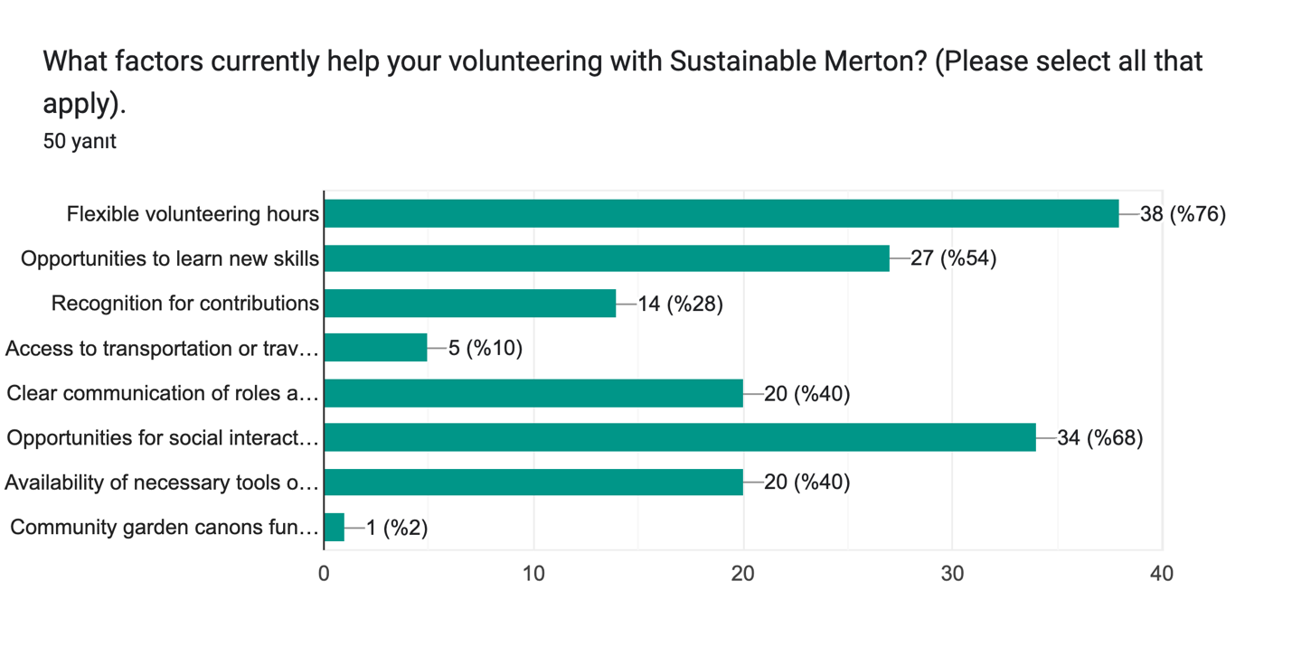

The survey results reveal several key facilitators that support volunteers in their roles with Sustainable Merton. According to the graph, flexible volunteering hours emerged as the most significant factor, cited by 76% of respondents, followed by opportunities for social interaction (68%) and learning new skills (54%). Other notable facilitators include clear communication of roles and expectations and the availability of necessary tools and resources, both mentioned by 40% of respondents. Open-ended responses further highlight additional insights: volunteers appreciate flexibility in scheduling, clearer project feedback, and recognition for their contributions. Suggestions for improvement include introducing more environmental/conservation projects, organizing volunteer staff meetings, and enhancing community engagement through shared activities like growing and distributing food. Some volunteers also emphasized the importance of better advertising for Sustainable Merton’s work and fostering a sense of independence in their roles. These responses collectively underscore the need for tailored strategies to enhance volunteer satisfaction and engagement while addressing specific areas for improvement.

Formlar yanıt grafiği. Soru başlığı: What barriers, if any, prevent or limit your engagement in volunteering?
(Please select all that apply.). Yanıt sayısı: 50 yanıt.

The survey results indicate key barriers that limit or prevent engagement in volunteering. The most significant barrier, identified by 72% of respondents, is a **lack of time due to personal commitments**, which highlights the competing demands volunteers face in their daily lives. Other notable barriers include **unclear communication about opportunities** (12%), **limited availability of resources** (10%), and a **lack of recognition or feedback** (10%). Accessibility issues and language or communication difficulties were mentioned by 6% and 4% of respondents, respectively, while **lack of financial support for transport** was identified by 4%.

Some volunteers also provided open-ended insights, emphasizing challenges like balancing **full-time work commitments**, **financial obligations**, or a need for clearer guidance and direction. While a minority indicated they are satisfied with their current engagement level, these responses collectively suggest a need for Sustainable Merton to address key barriers by providing more flexible volunteering schedules, clearer communication, and enhanced support for volunteers to make participation more accessible and rewarding.

In addition to the survey’s predefined barriers, volunteers shared several additional challenges through open-ended responses. **Time constraints** remain the most frequently mentioned obstacle, reflecting the difficulty of balancing volunteering with personal and professional commitments. Financial limitations were also highlighted, with one volunteer noting they would engage full-time if it were financially viable. Several respondents pointed out a lack of **awareness about volunteering opportunities**, including unclear communication on the website and insufficient engagement beyond specific social spheres.

Some responses suggest organizational challenges, such as **contradictory guidance from the council**, the absence of **volunteer staff meetings**, and a desire for better insights into how their contributions impact the community. One volunteer emphasized the importance of inclusivity, sharing an incident where an autistic individual faced barriers to participation. Additionally, there were concerns about volunteering being perceived as catering primarily to more affluent areas of Merton and overlooking hidden disabilities.

These insights underline the importance of addressing logistical, financial, and communication barriers while fostering inclusivity and providing clear, consistent guidance to create a more supportive and accessible volunteering environment.

Formlar yanıt grafiği. Soru başlığı: In what ways can Sustainable Merton provide better support to help you overcome the challenges you face?
(Select all that apply). Yanıt sayısı: 50 yanıt.

The survey results highlight various ways in which Sustainable Merton can better support its volunteers to overcome challenges. The most frequently suggested area for improvement is **creating more opportunities for social interaction** (44%), followed closely by **improving communication about opportunities** (42%). These findings underline the importance of fostering a strong sense of community and ensuring clear, accessible communication.

Other significant suggestions include **offering more flexible volunteering schedules** (30%), which aligns with the frequent barrier of time constraints, and **recognizing volunteer contributions** (20%), emphasizing the value of appreciation and acknowledgment. Additionally, **providing financial support for transport** and **better tools or resources** were each suggested by 14% of respondents, indicating the need for tangible support in facilitating volunteering activities.

A small proportion of respondents noted that they could not think of additional suggestions (8%), while a few open-ended responses emphasized the value of inclusivity and teamwork, such as allowing broader participation and improving collaboration across teams. These insights point to opportunities for Sustainable Merton to enhance volunteer satisfaction by addressing logistical challenges, improving communication, and strengthening the social and community aspects of volunteering.

1. **Volunteering Demographics**

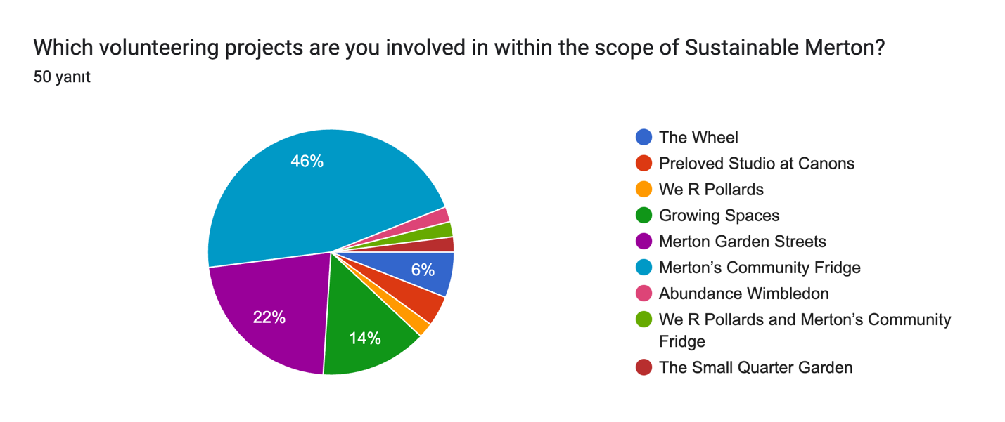

The pie chart provides an overview of the various volunteering projects under Sustainable Merton and the percentage of respondents involved in each. The majority of volunteers (46%) participate in Merton’s Community Fridge, indicating this is the most popular and impactful initiative. The next most common project is Merton Garden Streets, engaging 22% of respondents, reflecting its significant appeal among volunteers.

Other projects, such as We R Pollards (14%) and Growing Spaces (6%), have smaller but meaningful participation. A few volunteers are involved in more niche activities, including The Wheel, Preloved Studio at Canons, Abundance Wimbledon, We R Pollards and Merton’s Community Fridge, and The Small Quarter Garden, each accounting for a smaller share of respondents.

This distribution highlights the diverse range of opportunities provided by Sustainable Merton, with some projects having broader engagement, while others cater to more specialized interests within the volunteer community.

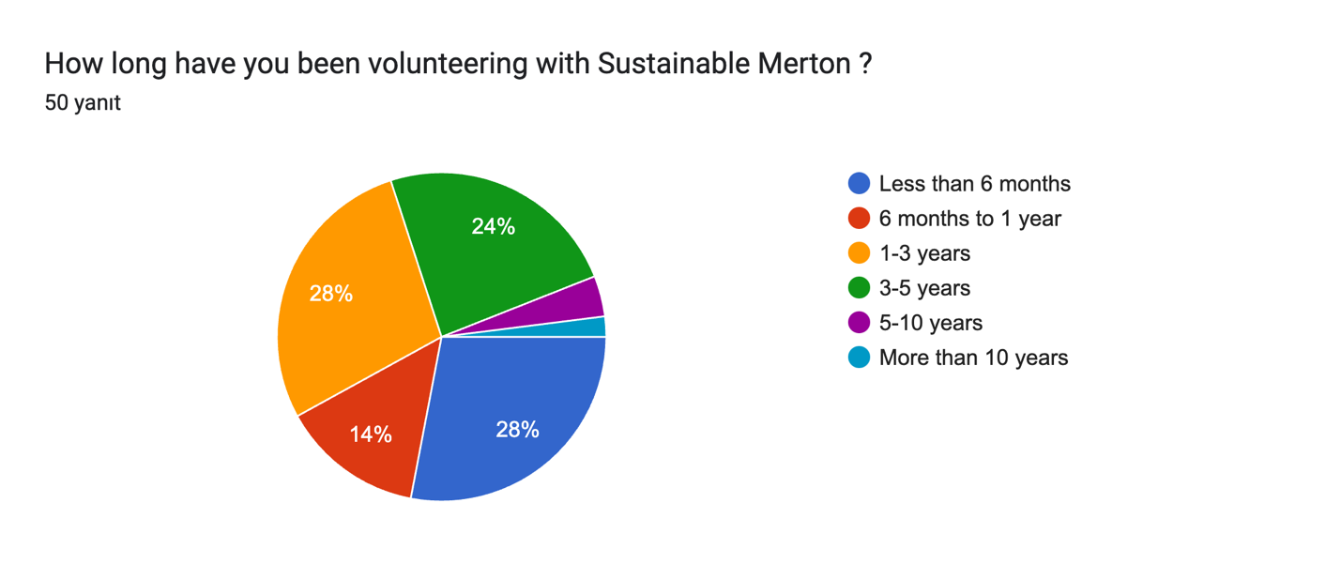

The pie chart illustrates the distribution of how long volunteers have been involved with Sustainable Merton. The largest segments are tied at 28% each, representing volunteers who have been involved for less than six months and those volunteering for 1–3 years. Another significant group, comprising 24%, has been involved for 3–5 years, indicating a solid retention rate over the medium term.

Smaller segments include those who have volunteered for 6 months to 1 year (14%) and long-term volunteers, with 5–10 years and more than 10 years accounting for a minimal share. This distribution suggests that Sustainable Merton has a healthy mix of newer and moderately experienced volunteers, while there may be opportunities to engage more individuals for extended commitments beyond five years.

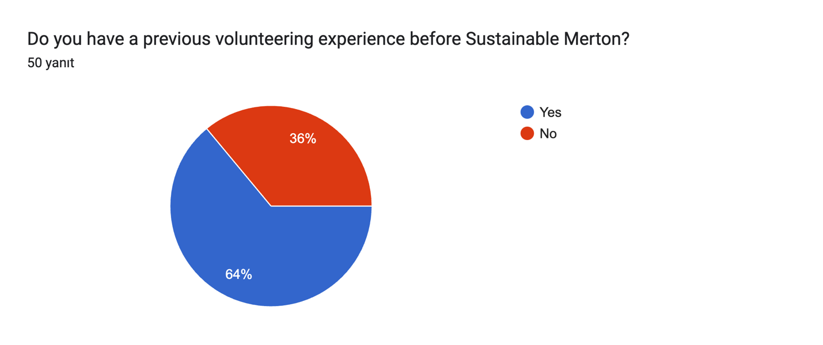

The pie chart shows that the majority of respondents (**64%**) had prior volunteering experience before joining Sustainable Merton, while **36%** did not. This indicates that Sustainable Merton attracts individuals with existing volunteer backgrounds, suggesting they may already have a predisposition toward community engagement and environmental causes. At the same time, a substantial proportion of first-time volunteers highlights the organization’s ability to appeal to newcomers, potentially broadening its volunteer base and fostering initial participation in sustainability-focused activities.

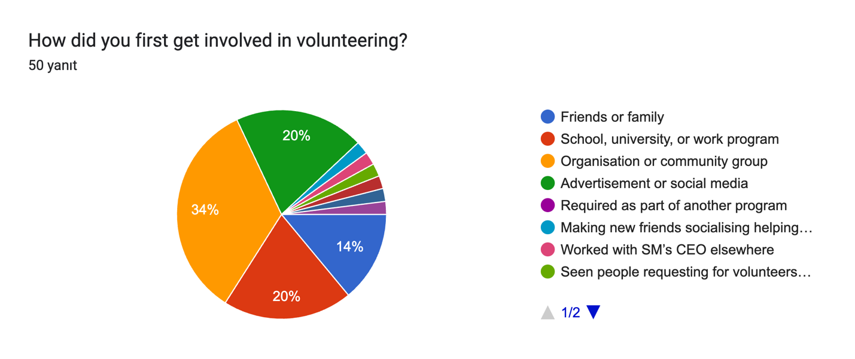

The pie chart illustrates how volunteers first got involved in volunteering. The largest share, **34%**, joined through an **organization or community group**, highlighting the central role these entities play in engaging volunteers. Another significant group, **20%**, began through **advertisements or social media**, emphasizing the importance of digital outreach in modern volunteer recruitment.

**Friends or family** (14%) and **school, university, or work programs** (20%) also play critical roles in introducing individuals to volunteering, demonstrating the influence of personal connections and educational/work environments. Smaller segments reflect diverse entry points, such as being **required as part of another program** or through unique situations like **working with Sustainable Merton’s CEO elsewhere** or **seeing requests for volunteers in the community**. These insights suggest that community connections, targeted advertising, and leveraging educational/work networks are effective strategies for volunteer recruitment.

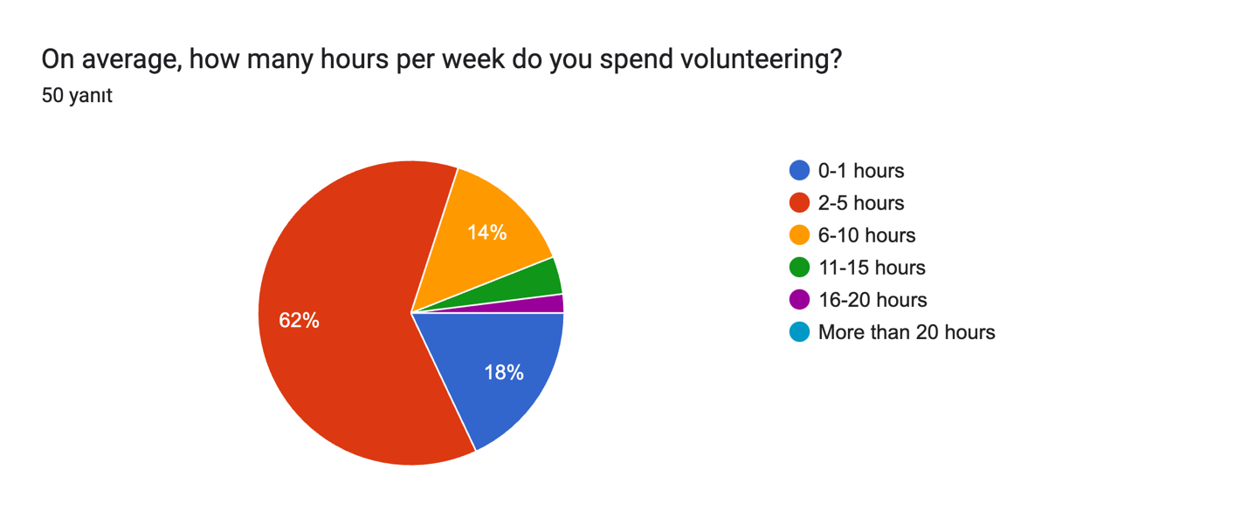

The pie chart shows the average weekly hours volunteers dedicate to Sustainable Merton. The majority of respondents (**62%**) spend **2–5 hours per week** volunteering, highlighting the part-time nature of most contributions. A smaller proportion (**18%**) volunteers for **0–1 hour**, while **14%** contributes **6–10 hours** weekly. Only a few volunteers dedicate significant time, with **11–15 hours** and **16–20 hours** each accounting for a minimal share.

These findings indicate that most volunteers engage at a manageable, part-time level, which aligns with the flexibility emphasized in other parts of the survey. Efforts to increase engagement might involve encouraging volunteers with smaller time commitments to gradually increase their involvement or creating micro-volunteering opportunities for those with limited availability.

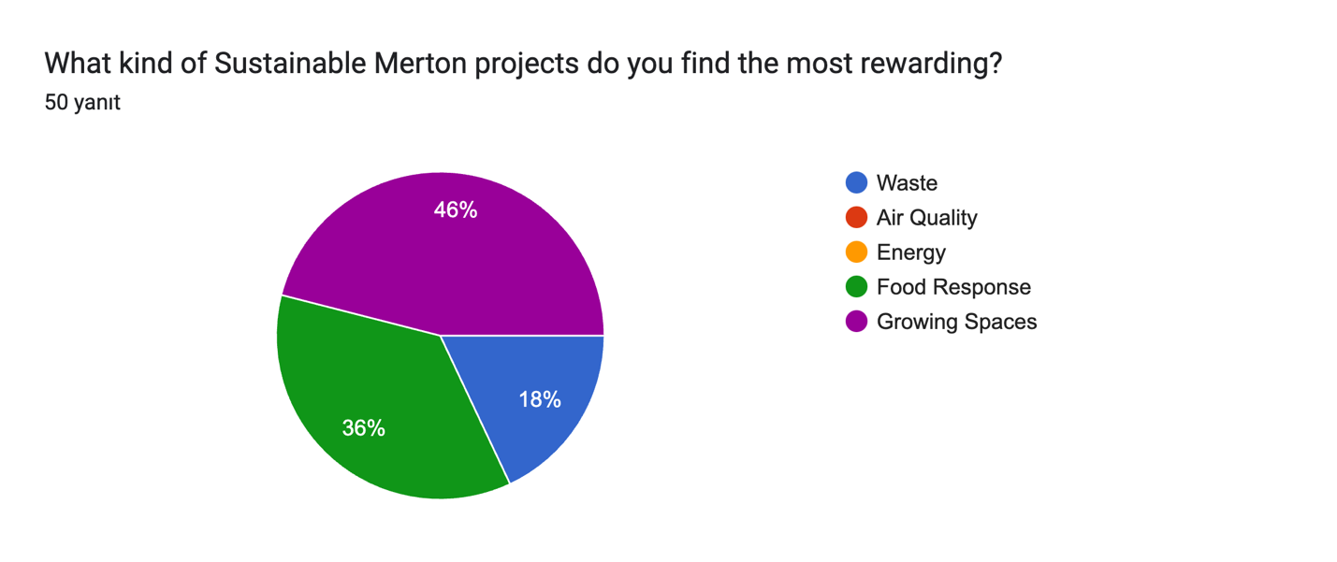

The pie chart shows which types of Sustainable Merton projects volunteers find the most rewarding. The majority of respondents (**46%**) identified **Growing Spaces** as the most rewarding, emphasizing the appeal of hands-on, community-centered environmental work. This is followed by **Food Response** projects, which were selected by **36%** of respondents, highlighting the impact and satisfaction derived from addressing food security and community needs.

Smaller segments represent projects focused on **Waste** (18%), while initiatives related to **Air Quality** and **Energy** were not highlighted as the most rewarding. These results suggest that projects involving tangible, direct contributions to the community and environment resonate most with volunteers, offering valuable insights for prioritizing future project designs and resource allocation.

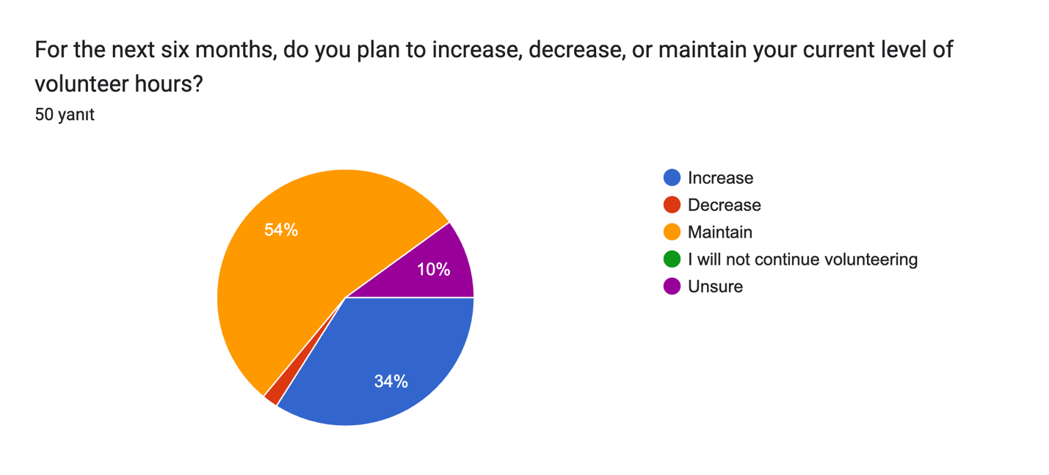

The chart reflects volunteers’ intentions regarding their level of commitment over the next six months. A majority (**54%**) plan to **maintain** their current level of volunteer hours, indicating satisfaction with their current engagement. A significant proportion (**34%**) expressed an intention to **increase** their hours, suggesting a strong sense of motivation and potential for greater involvement.

A small segment (**10%**) is **unsure** about their future engagement, while a minimal share intends to **decrease** their hours or discontinue volunteering. These findings highlight overall positive engagement levels among volunteers, with opportunities to encourage those aiming to increase their involvement and address the concerns of the few considering reduced participation.

Formlar yanıt grafiği. Soru başlığı: In the next two years are you likely to continue volunteering with this organisation?
. Yanıt sayısı: 50 yanıt.

The chart illustrates volunteers’ likelihood of continuing to volunteer with Sustainable Merton over the next two years, on a scale of 1 to 7. A majority (**56%**) gave the highest rating of **7**, indicating strong commitment to remaining involved with the organization. Another **18%** rated their likelihood as **6**, further highlighting positive engagement and intent to continue.

Smaller groups rated their likelihood as **5** (10%) or **4** (10%), showing moderate levels of commitment, while very few volunteers expressed low likelihood ratings (2% rated **2**, and none rated **1**). These results suggest that most volunteers have a strong intention to continue their engagement, reflecting high satisfaction and alignment with Sustainable Merton’s mission. Addressing the needs of volunteers with moderate or lower ratings could further enhance retention.

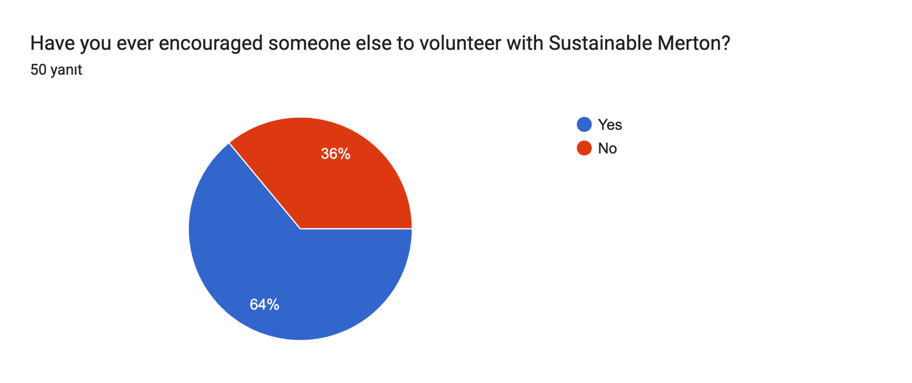

The pie chart shows that a majority of volunteers (**64%**) have encouraged someone else to volunteer with Sustainable Merton, reflecting strong advocacy and satisfaction among this group. Meanwhile, **36%** have not encouraged others to join. This demonstrates that while many volunteers are enthusiastic promoters of the organization, there is an opportunity to further engage and empower the remaining group to act as ambassadors for recruiting new participants. Enhanced communication about the impact of volunteers’ efforts and sharing success stories could help increase advocacy among all volunteers.

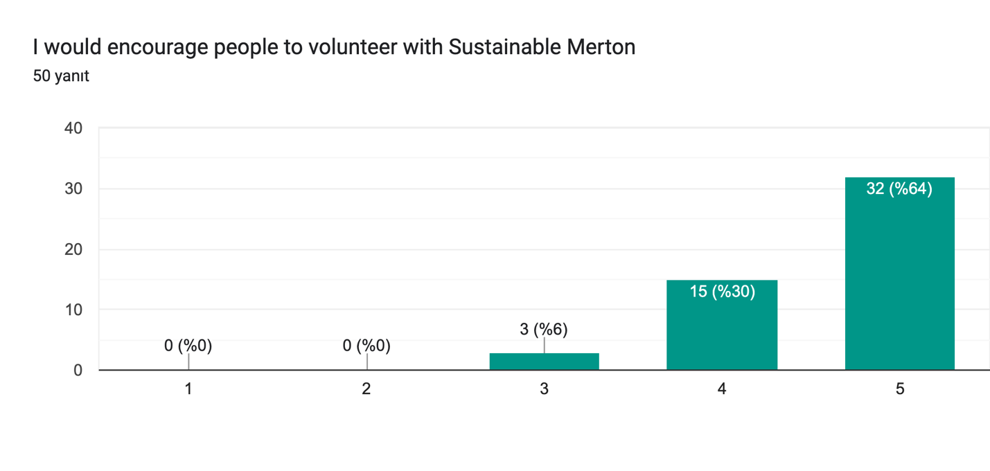

The chart reveals strong advocacy among volunteers for Sustainable Merton. A significant majority (**64%**) gave the highest rating of **5**, indicating they would highly recommend others to volunteer. Another **30%** rated their willingness as **4**, suggesting a high level of enthusiasm and satisfaction. Only **6%** rated their likelihood to encourage others as **3**, while no respondents rated it lower than that.

These results highlight the positive experiences of volunteers and their confidence in recommending Sustainable Merton to others, reflecting well on the organization’s impact and volunteer engagement practices. Leveraging this goodwill through referral programs or testimonials could further strengthen recruitment efforts.

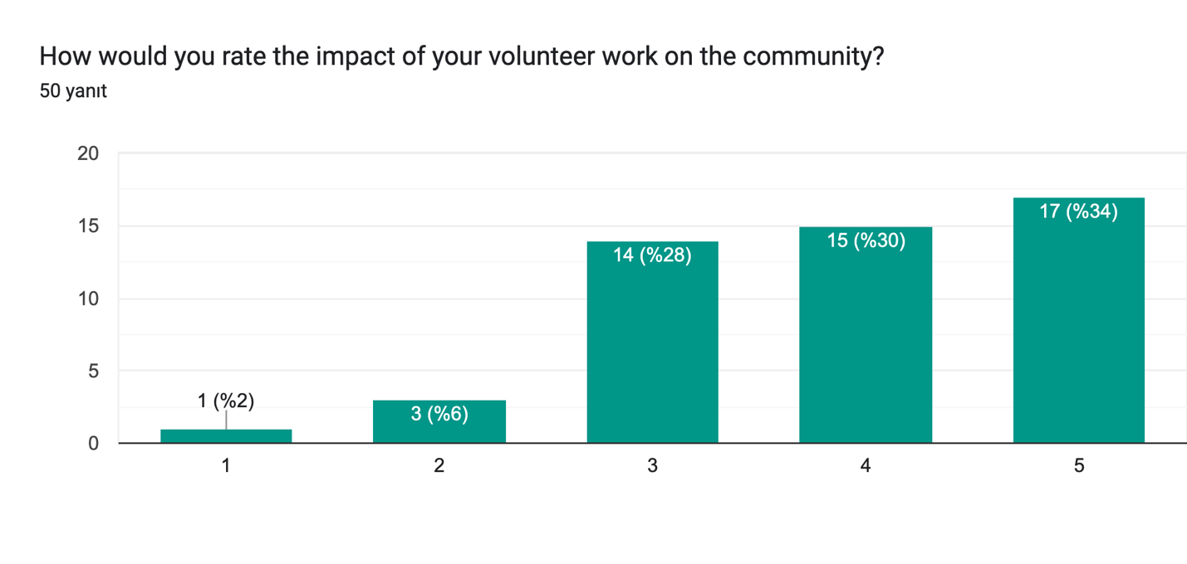

The chart shows how volunteers perceive the impact of their work on the community. A significant majority of respondents rated the impact positively, with **34%** giving the highest rating of **5** and **30%** rating it as **4**. Another **28%** provided a moderate rating of **3**, while a small minority rated the impact as **2** (6%) or **1** (2%).

These results indicate that most volunteers believe their contributions are making a meaningful difference, which aligns with high levels of engagement and satisfaction observed in other survey responses. However, the lower ratings from a small group suggest there may be room to enhance communication around the tangible outcomes of volunteer efforts to reinforce their sense of impact.

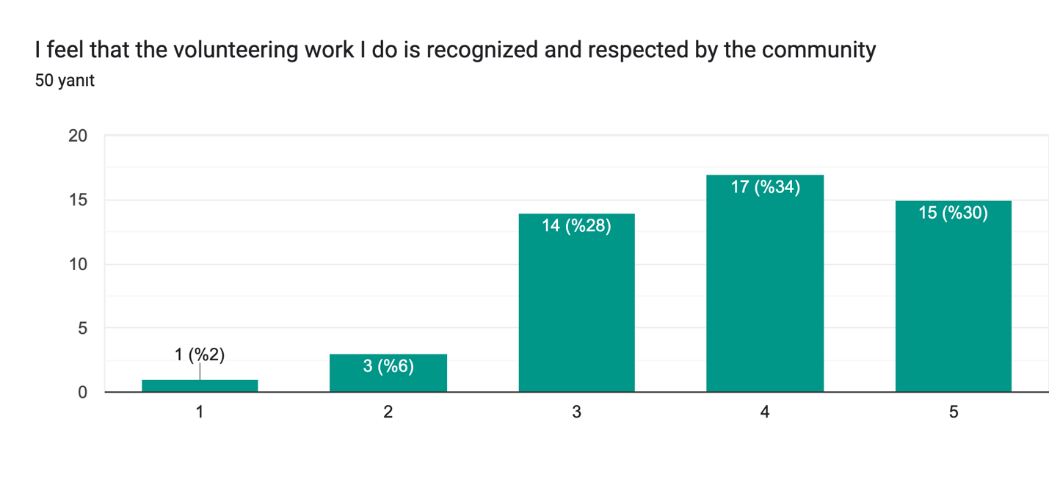

The chart reflects how volunteers perceive the recognition and respect their work receives from the community. A majority of respondents provided positive ratings, with **34%** rating it as **4** and **30%** giving the highest rating of **5**. This indicates that many volunteers feel valued for their contributions.

However, a notable portion (**28%**) rated their experience as moderate (**3**), and a small minority (**6%** and **2%**) rated it negatively (**2** or **1**, respectively). These results suggest that while most volunteers feel appreciated, there may be opportunities to enhance recognition efforts to ensure all volunteers feel their work is acknowledged and respected. Initiatives such as public acknowledgment, personalized feedback, or celebrating achievements could help address this gap.

* + **Analyze relationships between:**
    - Project involvement and motivations using chi-square tests.
    - Hours volunteered with satisfaction, engagement, and demographic variables using linear regression.

1. **Sustainability Awareness**

* **Sustainability Awareness:** Analysis to explore whether sustainability awareness has a meaningful relationship with motivations, engagement, and satisfaction.
* Use descriptive statistics to summarize sustainability-related responses (e.g., familiarity with sustainability, impact perception).
* Explore relationships between sustainability awareness and motivations, engagement, and satisfaction using correlations or simple regression.
* Frame these analyses as exploratory due to limited survey depth.

1. **Communication Preferences**

* **Communication Preferences:** Regression or correlation analysis to test whether the perceived effectiveness of communication channels predicts satisfaction, engagement, or intent to remain.
* Analyze perceived communication effectiveness as a predictor of satisfaction, engagement, or intent to remain using linear regression.
* Summarize communication challenges (e.g., delayed responses, overwhelming volume) using frequencies and thematic coding.
* Examine relationships between communication preferences and demographic variables using chi-square tests.

1. **Compare new volunteers to old volunteers:**
   * Categorize volunteers into new (<1 year) and old (>1 year) groups.
   * Compare key metrics (satisfaction, engagement, motivations, perceived impact, respect) using:
   * t-tests for two groups (e.g., new vs. old volunteers).
   * ANOVA for more detailed tenure categories (e.g., <6 months, 1-3 years, etc.), supplemented by post-hoc tests if significant.
   * Analyze intent to remain (e.g., "In the next two years, are you likely to continue volunteering?") using logistic regression or chi-square tests.
2. **Decision trees** 
   * Use decision trees to identify demographic predictors of satisfaction or engagement. Simplify models to avoid overfitting.
   * Avoid random forests due to the limited sample size.
   * Present results visually (e.g., feature importance rankings).
3. **Open-Ended Questions**
   * For open-ended questions like "What motivates you in your own words?", you can process responses by first cleaning the text (removing stopwords and standardizing formatting). Use keyword extraction techniques like TF-IDF or word clouds to identify frequently mentioned terms. Apply thematic analysis or clustering methods (e.g., LDA) to group responses into themes such as altruism, career growth, or social connections. Sentiment and emotional analysis tools can gauge emotional tones (positive, neutral, negative), while coding responses into categories enables frequency analysis (e.g., 40% altruism, 30% career). To deepen insights, correlate these themes with variables like engagement or satisfaction using regression or chi-square tests. Finally, visualize findings with bar charts or heatmaps to reveal patterns across demographics or other factors. This approach converts qualitative responses into actionable, quantitative insights.
   * If there are certain limitations like time, prioritise simpler thematic coding and keyword extraction for processing open-ended questions. Start by manually reviewing responses to identify common themes (e.g., "altruism," "career growth," "social connection"). Assign responses to these themes and calculate their frequencies to identify dominant categories. Use basic keyword analysis with tools like Excel or simple Python scripts to extract frequently mentioned words or phrases. This streamlined approach provides meaningful insights without requiring advanced techniques like LDA, making it more practical for immediate analysis and reporting.
4. **Reporting and Practical Implications**
   * Use clear visualizations (bar charts, scatterplots, heatmaps) to present findings.
   * Provide actionable recommendations for:
     + Enhancing facilitators and addressing barriers.
     + Improving communication strategies.
     + Retaining new and old volunteers by targeting motivations and satisfaction.
   * Emphasize limitations (small sample size, lack of validated commitment scale) in your reporting.